Parts list
This is the parts list for v1.2 ONLY! If you have a v1.0 or v1.1 kit this list will be incorrect! See below for the v1.0/v1.1 parts list guide
Check to make sure your kit comes with the following parts.Sometimes we make mistakes so double check everything and email support@adafruit.com if you need replacements!
Image | Name | Description | More info | Qty
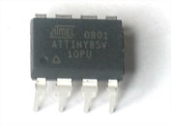 | IC1 | Microcontroller (preprogrammed when purchased in a kit) | ATTINY85V-10-PU  (unprogrammed when not purchased from Adafruit) | 1
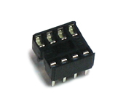 | IC1' | 8-pin socket | Generic | 1
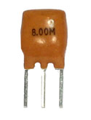 | XTL1 | 8.00 MHz ceramic oscillator. It might also be blue. | 8mhz ceramic resonator | 1
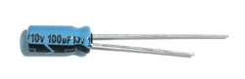 | C1 | 220uF or higher capacitor with 6.3V or higher rating | Electrolytic Capacitor | 1
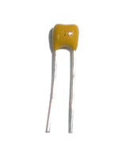 | C2 | Ceramic 0.1uF capacitor (104) | Ceramic Capacitor | 1
 | R2 | 1/4W 5% 10K resistor  For EU configuration use!  Brown, Black, Orange, Gold | Generic Resistor | 1
 | R1, R3 | 1.0Kohm 1/4W 5% resistor (brown black red gold) | Generic Resistor | 2
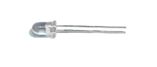 | LED3, LED4 | Narrow beam IR LED. These have a blue-ish tint. | Everlight IR333-A | 2
 | LED2, LED5 | Wide beam IR LED | Everlight IR333C/H0/L10 | 2
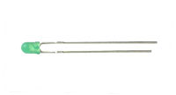 | LED1 | 3mm LED | 3mm green diffused | 1
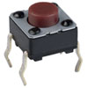 | SW1 | 6mm tact switch button | 6mm tact switch | 1
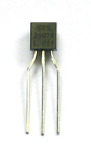 | Q1 | PNP transistor, EBC pinout  Such as PN2907 or 2N3806 | PN2907 | 1
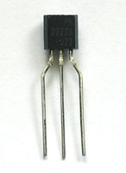 | Q5 Q2 Q3 Q4 | NPN Transistor (TO-92) that is pin compatible with 2N3904 EBC pinout | PN2222 | 4
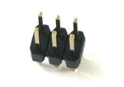 | ICSP | 6 pin header, 0.1"x0.1" spacing | 2x3 header | 1
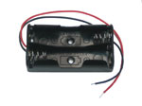 | BATT | 2 x AA battery holder | Keystone 2463 | 1
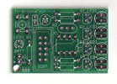 | PCB | Circuit board | Adafruit Industries | 1

